PARISH BULLETIN ANNOUNCEMENTS
To promote the Create Hope: Reaping our Rights campaign, please request to have these 2024 Share Lent announcements from Development and Peace — Caritas Canada published in your parish’s bulletin. Ideally, the messages should be published over seven consecutive weeks, starting February 11, 2024.
For publishing in the bulletin, please use the higher-resolution images available here.
Pre-Lenten announcement: February 11
This Lent, let’s work toward Reaping our Rights
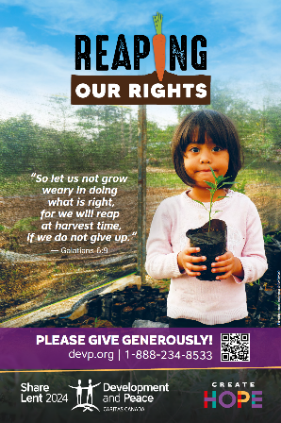
This year, Development and Peace — Caritas Canada’s Create Hope: Reaping our Rights campaign calls you to stand with small-scale farmers and peasant communities who feed the world while caring for the Earth. Do this by:
- Donating online at devp.org/give or during the Solidarity Sunday collection on March 17, the fifth Sunday of Lent. Your generosity helps support over 73 projects in 36 countries around the world!
- Learning more by reading the Mini-magazine and other resources available at devp.org/lent/resources.
- Meeting our solidarity visitors and participating in the campaign launch webinar on February 17 at 1:30 p.m. ET.
For more information, contact [Name of the local Development and Peace ― Caritas Canada contact person] at [Telephone number] or [Email address].
Week 1: February 18
Development and Peace — Caritas Canada: a movement of solidarity
Established in 1967, Development and Peace ― Caritas Canada is the official international solidarity organization of the Catholic Church in Canada.
We address the root causes of poverty, oppression, and inequality by working with partners in the Global South and by mobilizing Canadians in the common struggle for justice and dignity. We champion women and social movements as key agents of lasting change.
Our transformative work is possible thanks to the generosity and support of our members and Canadians who stand by us.
Join the movement of over 12,000 members and help us bring our campaigns to life in your community. Visit devp.org/membership.
Week 2: February 25
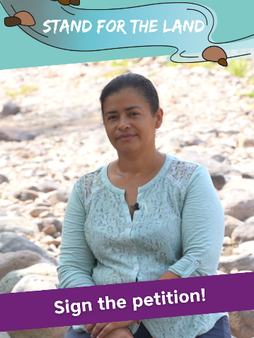
Last chance to sign the Stand for the Land petition
Today is the deadline for signing a letter to Honduran ambassador to Canada asking her government to protect those who are fighting to defend forests and rivers in a Honduran national park against pollution from a mine. The letter is part of Development and Peace ― Caritas Canada’s last fall campaign.
Over 20,000 Canadians have signed it in solidarity with these struggling communities of Guapinol and the San Pedro sector. Join the effort and add weight to our demands. Sign now at devp.org/act.
Thank you for your solidarity!

Week 3: March 3
Denouncing oil pollution in Nigeria
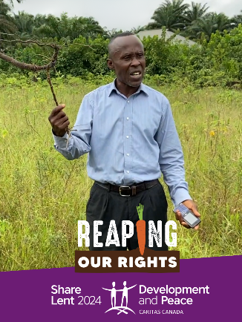
Nigeria is Africa’s largest economy and biggest oil producer. Despite oil exports worth billions of dollars, millions of Nigerians remain in poverty and face food insecurity. In the south, pollution and contamination by the oil industry are causing great hardship.
Development and Peace — Caritas Canada’s partner Health of Mother Earth Foundation (HOMEF) defends farmers’ rights and helps protect their lands.
To learn more about the work of HOMEF, read our Mini-magazine and watch the video at devp.org/lent.

Week 4: March 10
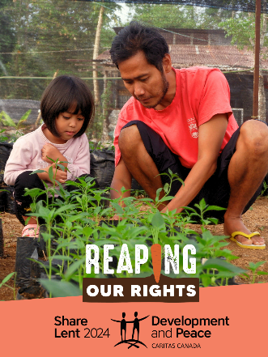
Training next-generation farmers in Indonesia
In rural Indonesia, young people are abandoning agriculture to work in cities. Over time, this could threaten food sovereignty.
Our partner PAYOPAYO empowers village communities to work together to find solutions to common challenges related to agriculture, food, energy, natural resource management and the engagement of youths, especially women.
This Lent, meet our solidarity visitor Karno Batiran, the executive director of PAYOPAYO. Learn more at devp.org/lent.

Week 5: March 17 – Solidarity Sunday
This Lent, please give generously
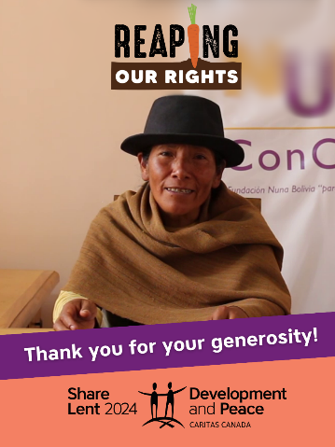
This Solidarity Sunday, Development and Peace ― Caritas Canada’s Reaping our Rights campaign invites you to give generously and thanks you warmly for your generosity.
Your donation transforms the lives of some of our most vulnerable sisters and brothers across the world.
“Development and Peace — Caritas Canada accompanies, supports and respects our institutional autonomy. It creates a climate of trust. I thank our sisters and brothers in Canada for their solidarity, a solidarity that generates life opportunities, that accompanies the dreams of women and men, of families, of communities and territories. Thank you!” ― Eva Colque, Executive Director, Fundación NUNA, a partner in Bolivia
Help create hope and dreams of the communities we support in the Global South by giving to your Share Lent parish collection or at devp.org/give. Thank you for your solidarity!

March 24 (or as soon as the results of the fundraising campaign are known)
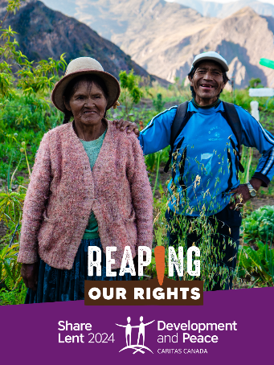
Thank you for giving from the heart to Share Lent 2024!
Development and Peace — Caritas Canada thanks you for supporting the Reaping our Rights campaign with your Share Lent donation. Thanks to your generosity, our parish collected [$ amount]. This sum will help support our sisters and brothers in Africa, Asia, Eastern Europe, Latin America and the Middle East.
If you have not yet had a chance to give, you can still place your Share Lent envelope in the offertory or donate online at devp.org/give.
Thank you for continuing to pray for all those who are working to build a world of peace and justice.

